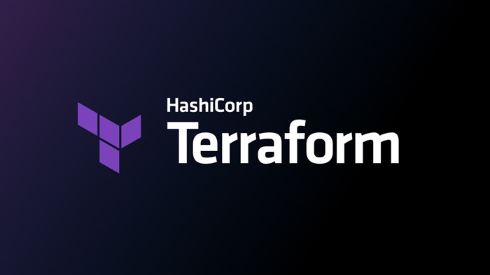
TERRAFORM 02
Title:
Execute all the templates shown in the video.
Integrate Terraform in Jenkins using the Terraform plugin.
Implementation:
Lifecycle Rules
1. create_before_destroy
- Ensures a new resource is created before the old one is destroyed.
- Prevents downtime during replacement.
A normal syntax without lifecycle rules and the file was destroying first and creating after
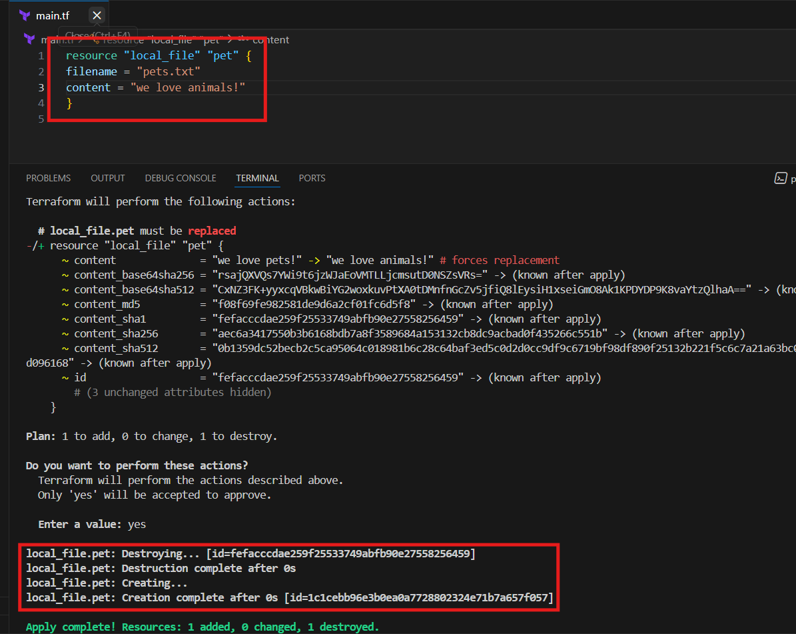
After implementing lifecycle rules the file created first and deleted later
And provide the rule as “true”
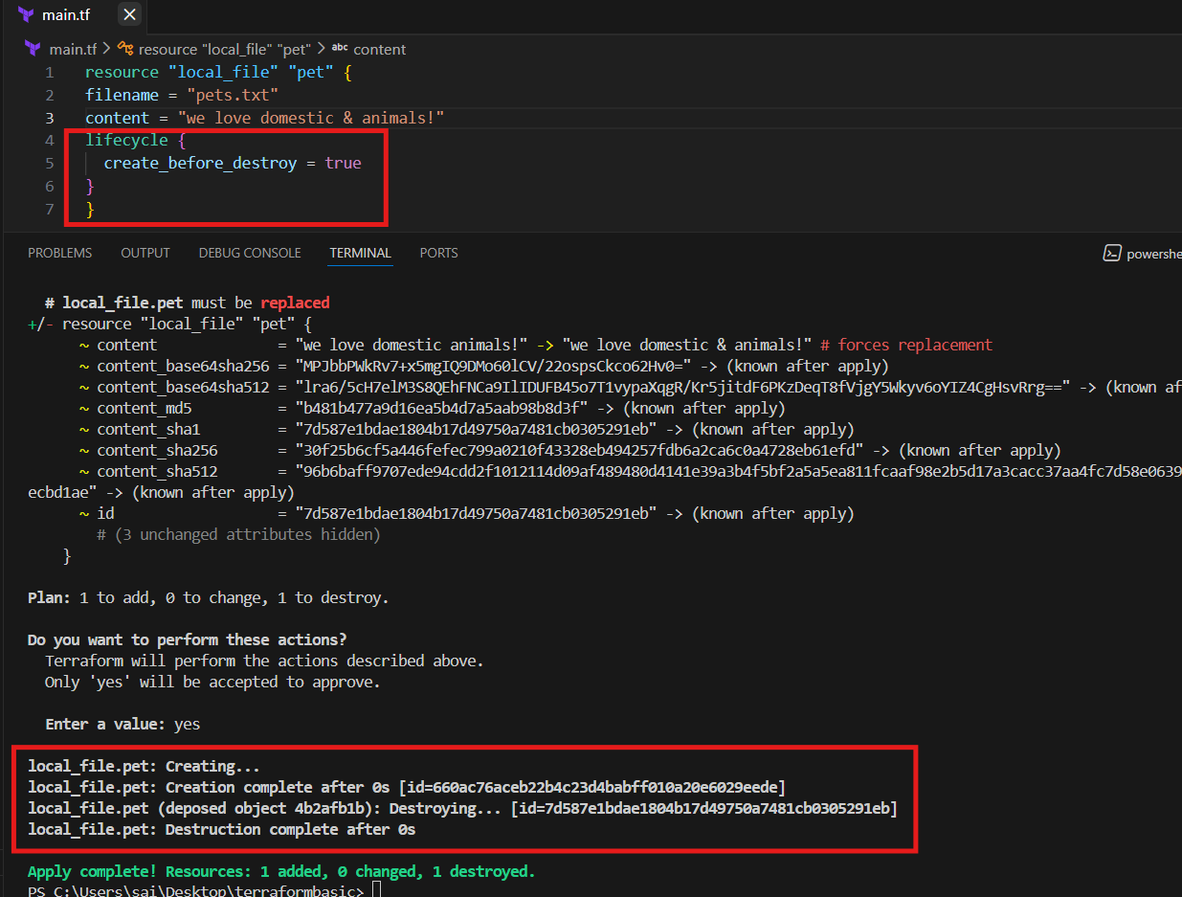
Changed the lifecycle rule to false so that again it was destroyed the file and created the new file like earlier
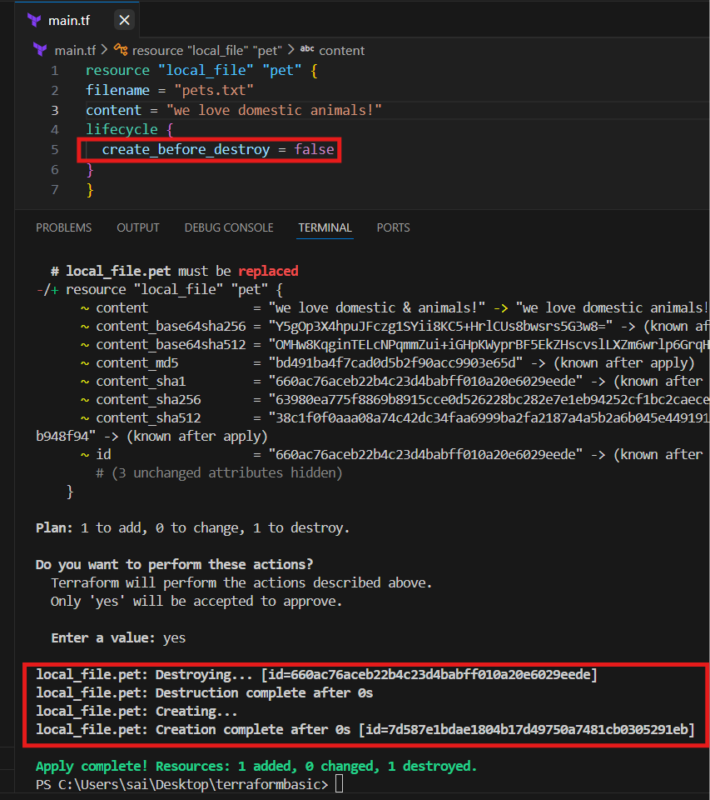
2. prevent_destroy
- Protects a resource from accidental deletion.
- Even if you run terraform destroy, Terraform will error out instead of removing it.
Testing by keeping false as destroy and file was destoyed
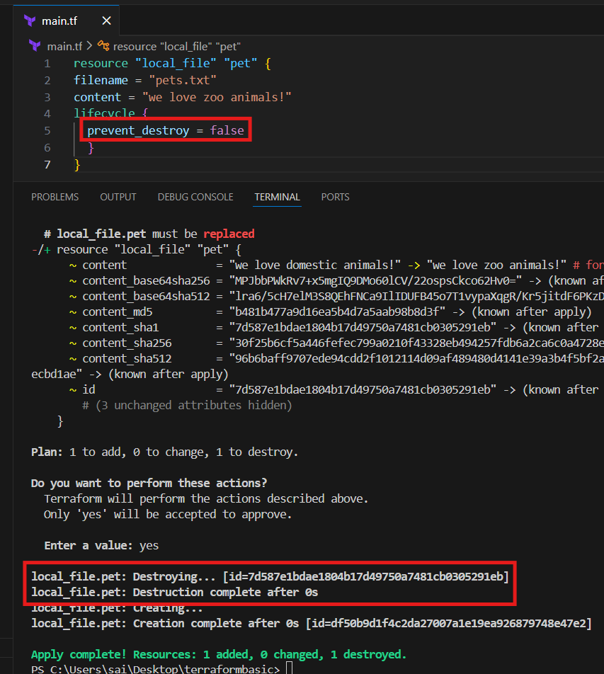

Why Terraform can’t proceed
prevent_destroy means:
“If this resource would ever be destroyed for any reason, fail instead.”
A replacement always includes a destroy, so Terraform refuses.
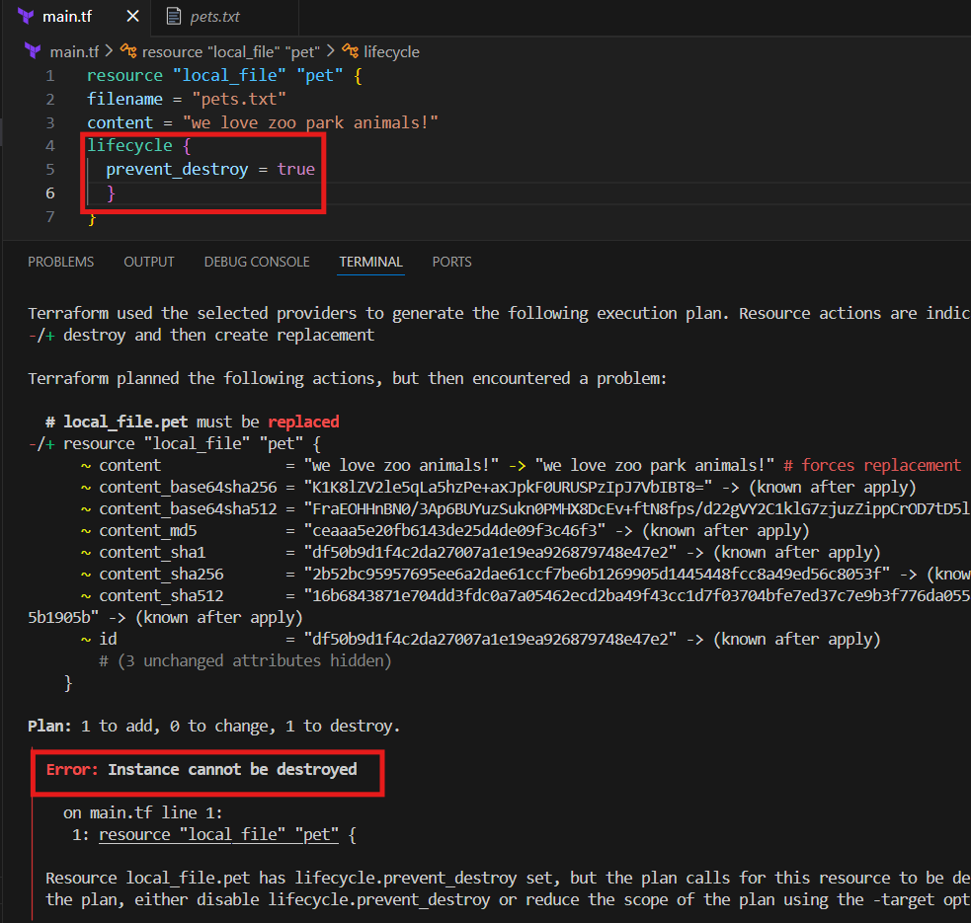
Terraform is correct — changing content requires destroying and recreating the file, but prevent_destroy = true blocks that, so Terraform fails as designed.

3. ignore_changes
- Tells Terraform to ignore specific attributes if they change outside Terraform.
Changed the content and performed the execution and terraform ignored it
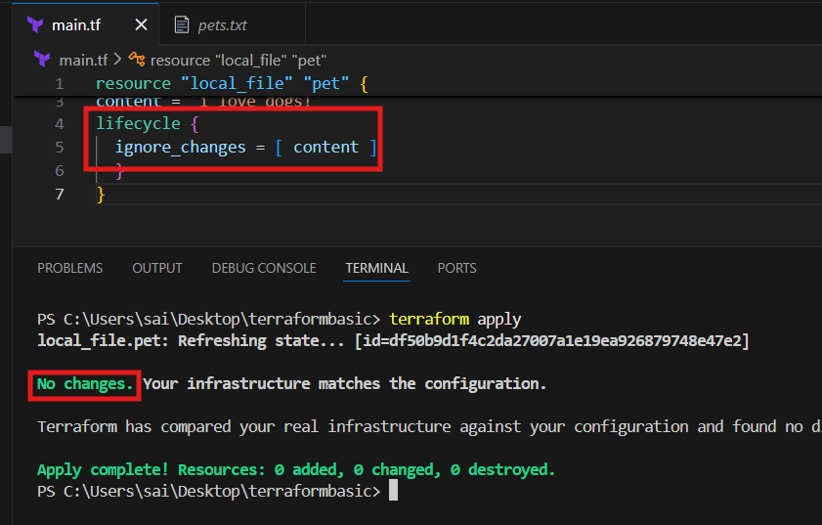

As part of validation I ignored the filename instead of content, and I changed the content but not file name so that the execution was normal
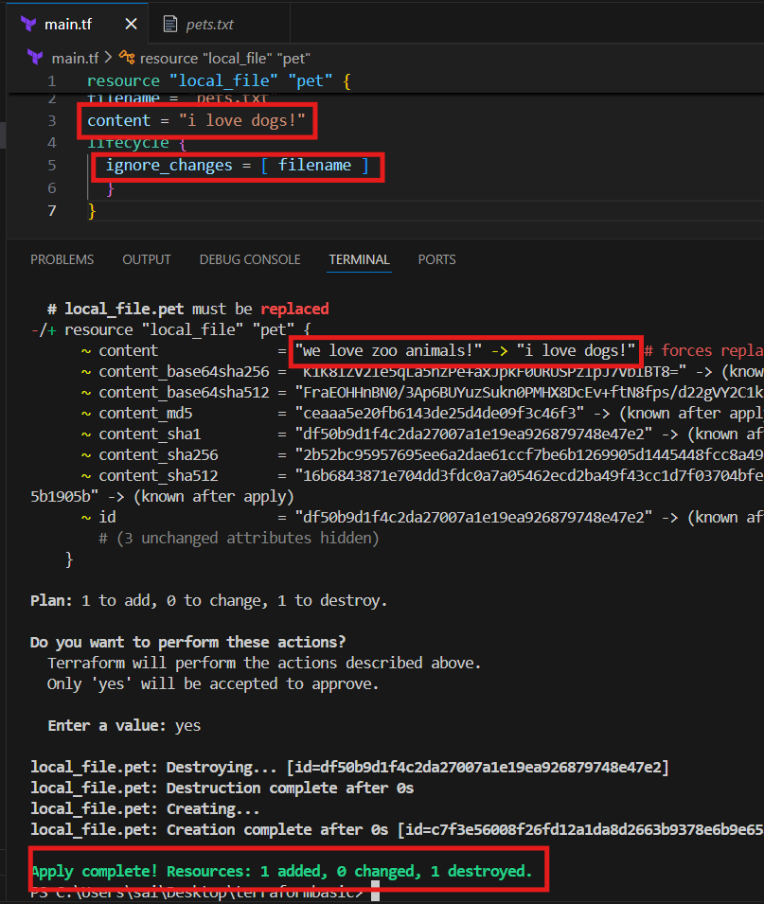

4. replace_triggered_by (newer versions)
It forces Terraform to destroy and recreate this resource whenever the referenced resource (or attribute) changes — even if this resource itself didn’t change.
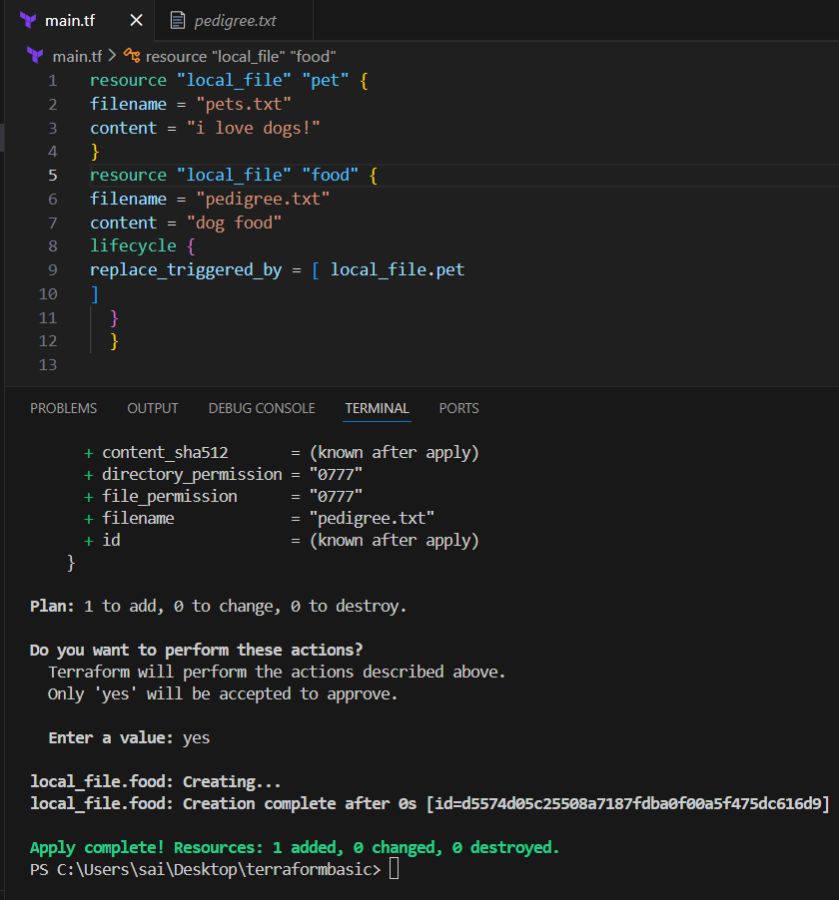

Explanation:
- changed pet ("i love dogs!" → "i love cats!")
- Terraform cannot edit the file in place, so it deleted and recreated pet
- You told Terraform:
👉 “If pet changes, recreate food too”
- So Terraform deleted and recreated food as well
Changing the pet file forced its replacement, and because food uses replace_triggered_by = [local_file.pet], Terraform correctly destroyed and recreated both resources in the apply.
the order:
- Destroy food
- Destroy pet
- Create pet
- Create food
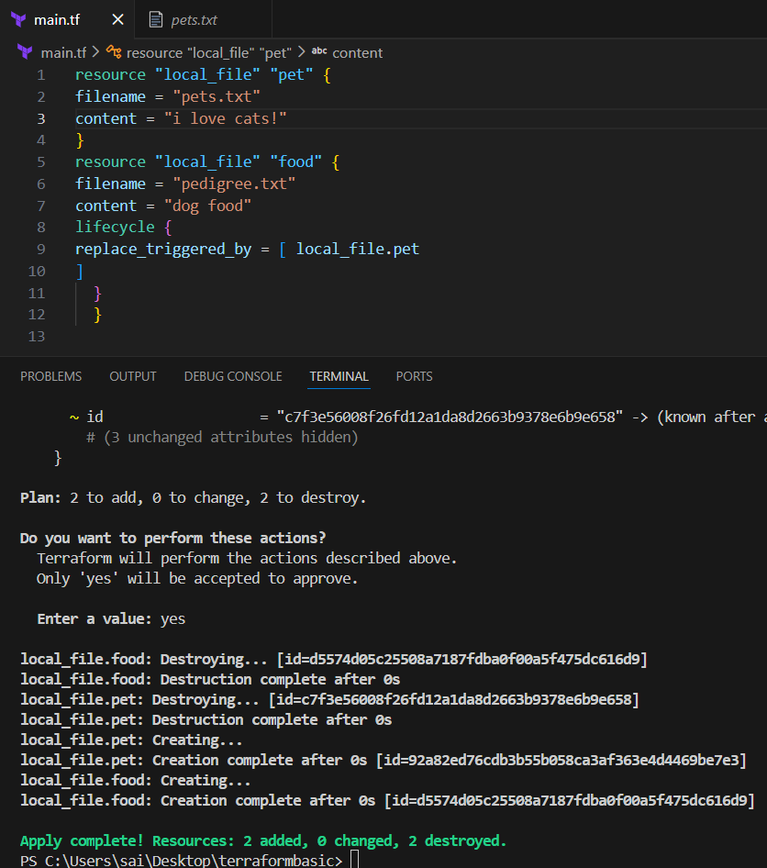
Variables:
Formal syntax
- Create a file naming with variables.tf and add a syntax
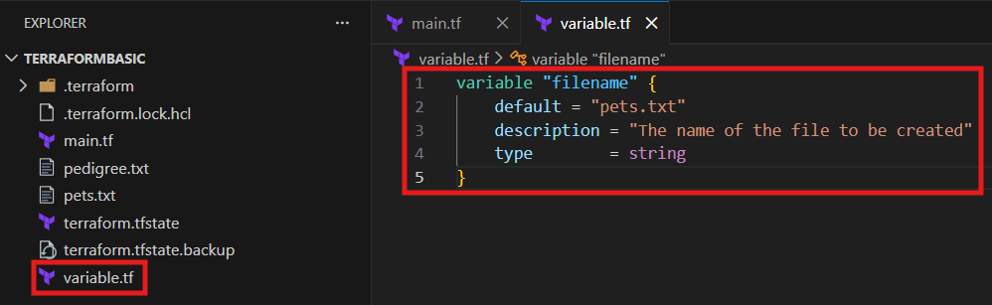
In Terraform, a String variable is used to hold plain text values. It’s the most common type because many resource arguments (like names, IDs, regions) are expressed as text.
variable "instance_type" {
type = string
description = "EC2 instance type"
default = "t2.micro"
}
Before
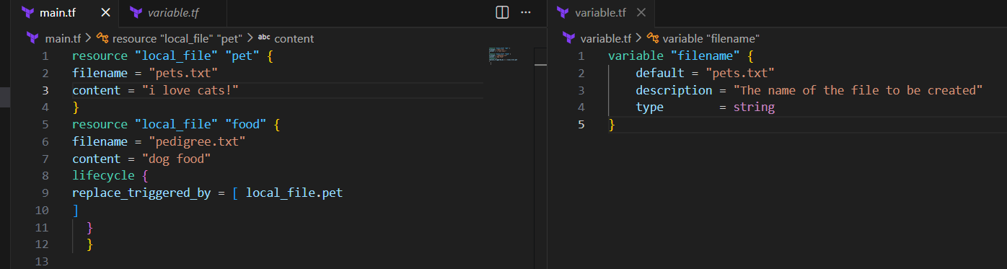
After changed the content and provided the variable name in code not the info
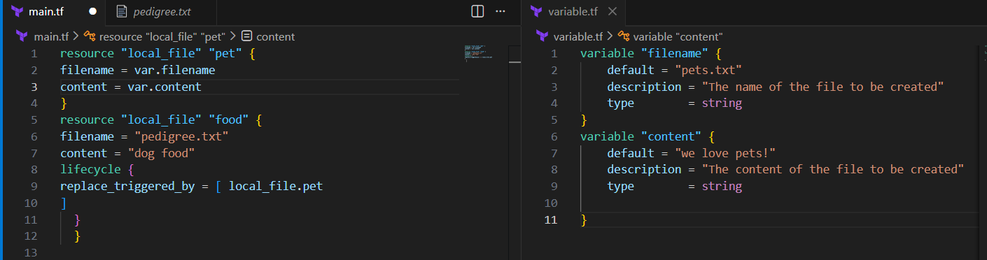
Successfully changed it to new one..
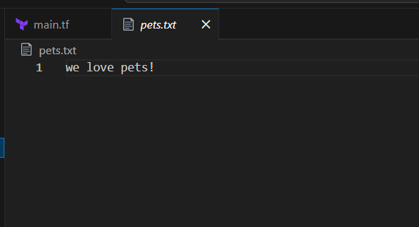
- Type: string
- Default: Optional fallback value
- Description: Documentation for clarity
- Usage: Reference with var.instance_type

Using two resources for example
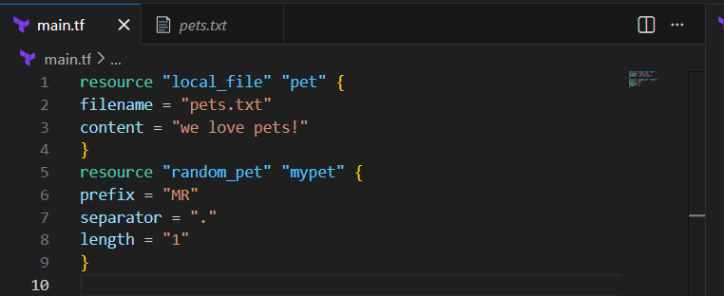
Added a variables file and inserted data into it.
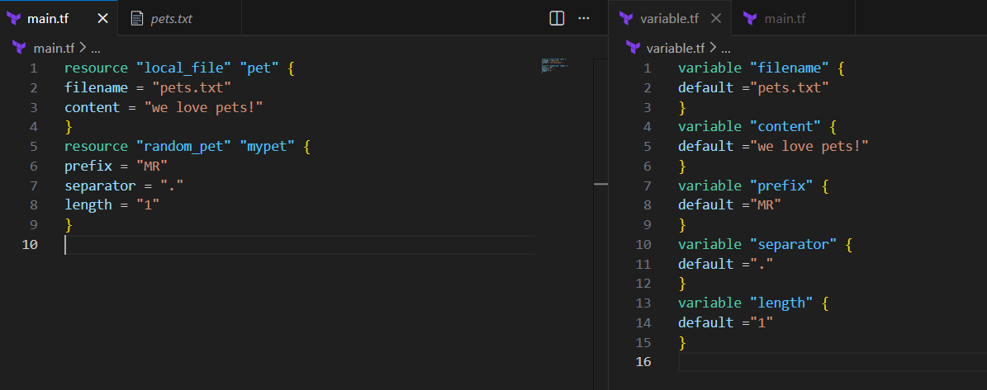
Changed the main.tf file accordingly to variable.tf file
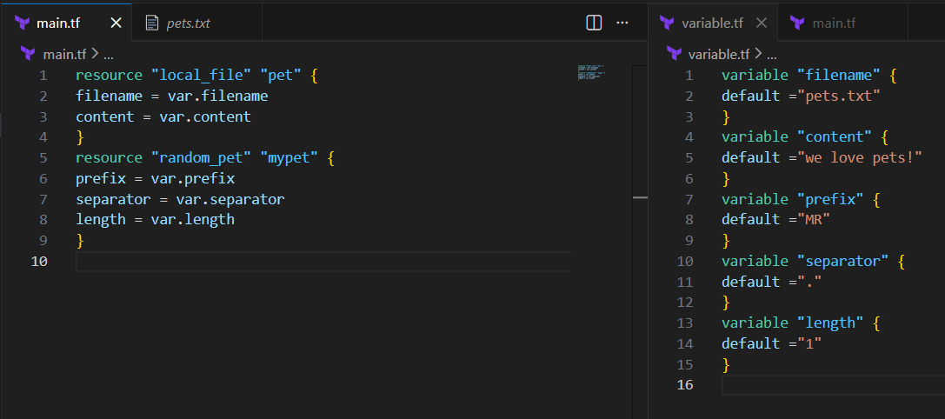

Executed using terraform apply and details were added or changed
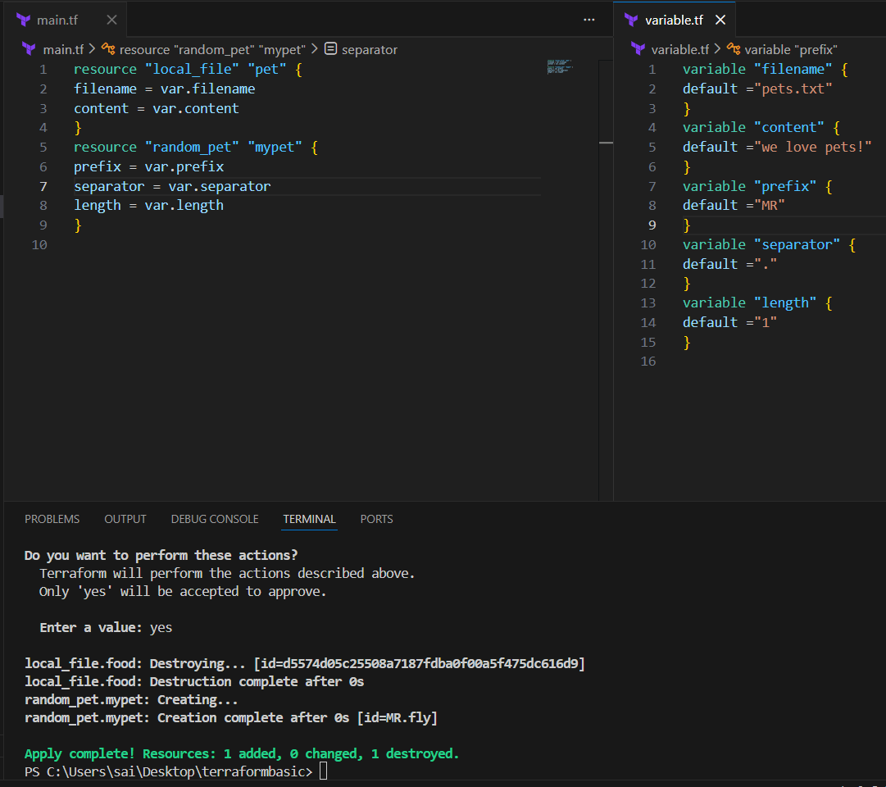
Validation:
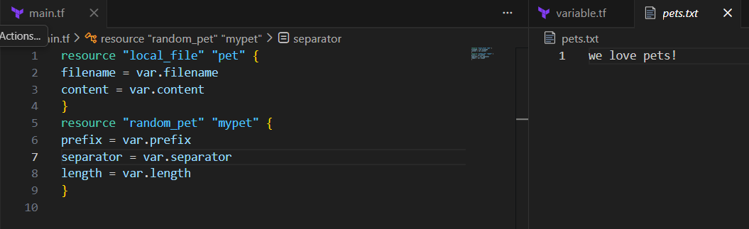

Again performed by changing data in variables and executed
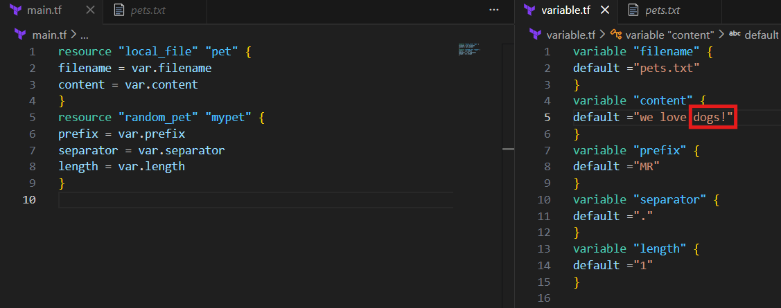
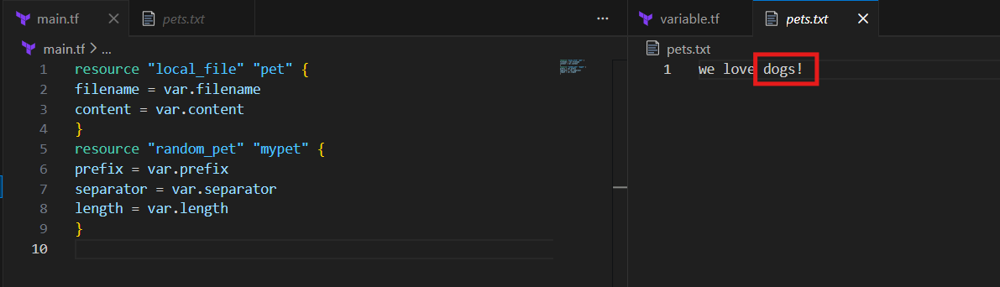
Taking user input to add data
Create a file naming variable.tf but keep empty like in below image
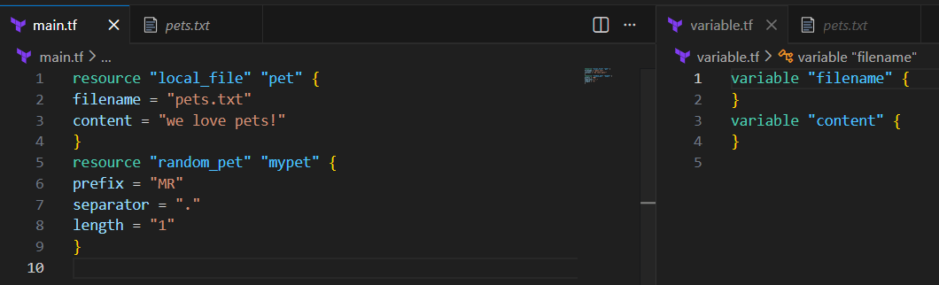
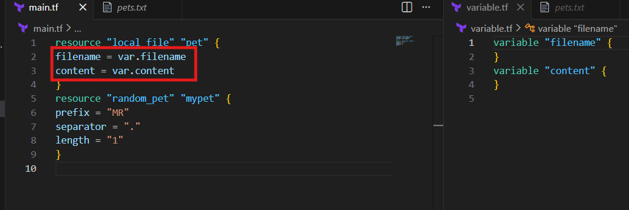
The user is requested to add the info after adding the actions will be performed
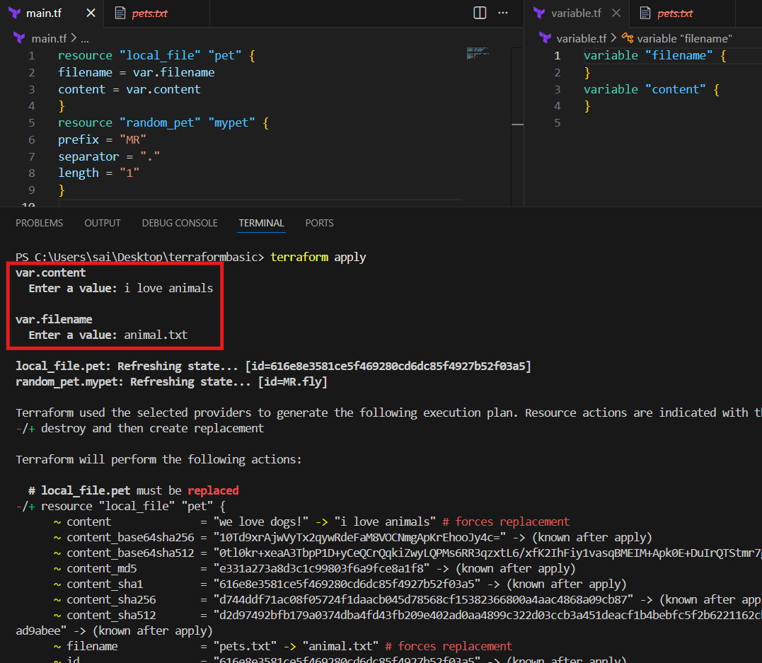
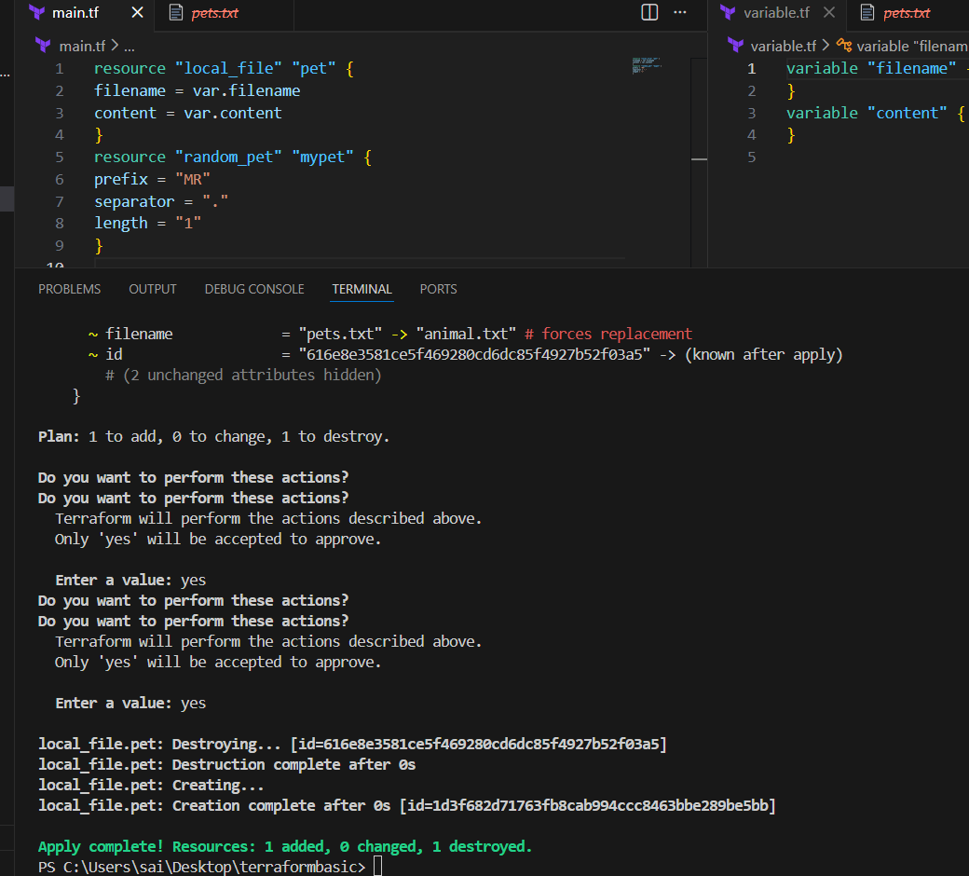
Now adding the data using command line interface
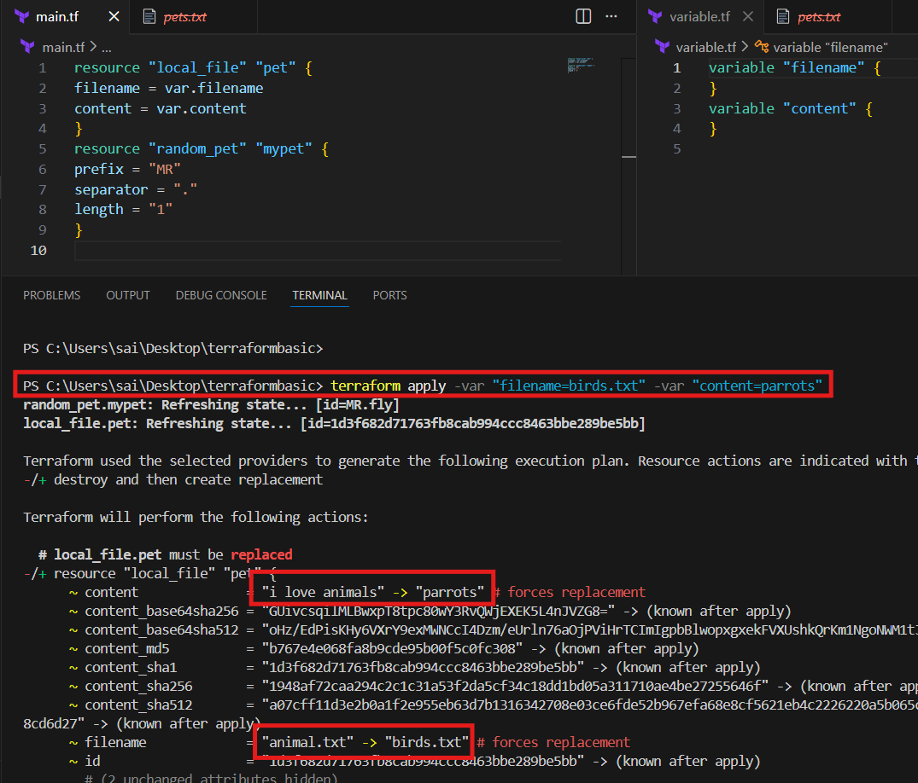
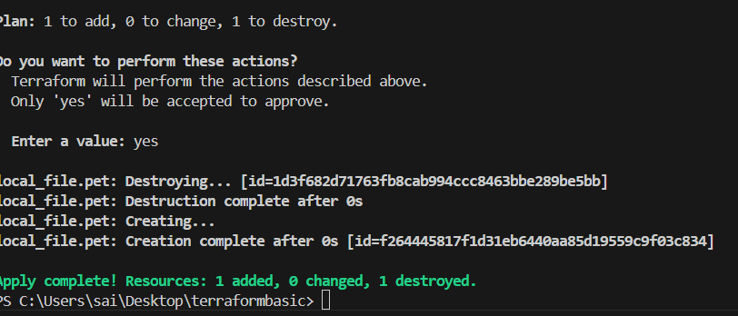
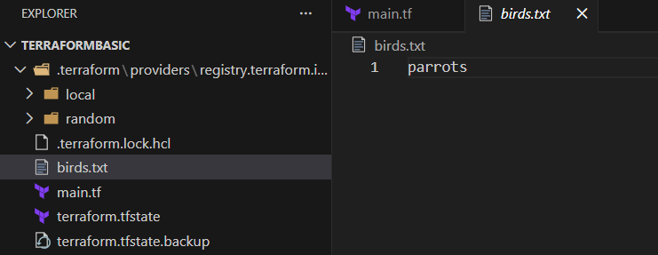
Conclusion:
Passing variables through the CLI (-var) changed both the filename and content, so Terraform correctly replaced the existing file by destroying the old one and creating a new file (birds.txt) with the new content (parrots).

